Name___________________________________________ Date ________ Period ________
Renewable Energy

Q (A 99): What makes renewable energy attractive? What makes renewable energy unattractive?
- They are in unlimited supply and produce little or no pollution.
- So, far, however, these resources cannot produce enough energy to pay for the cost of developing them on a large scale. Scientists and engineers must improve the necessary technologies before renewable energy sources can supply clean energy to more of the world's people.
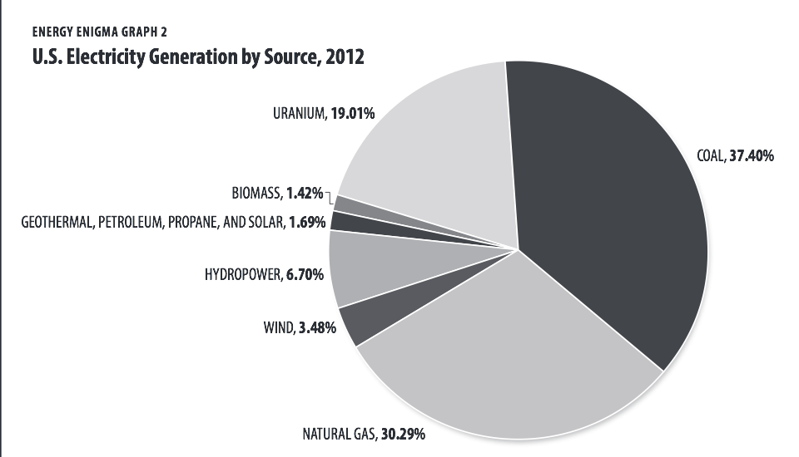

ENERGY SOURCE: Hydroelectric Energy
1. How is energy made? Where does the energy come from? (A 100)
energy that comes from the force of moving water.

2. Major uses: __electricity________________________
3. How is electricity made from this source? Highlight special equipment needed.
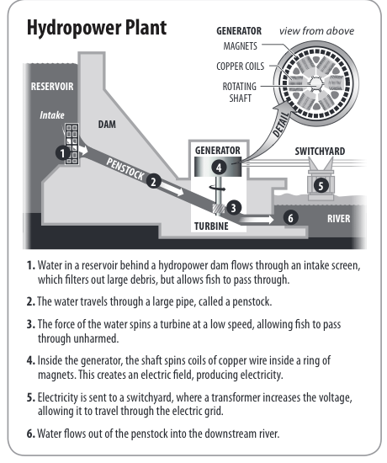
In most cases, a dam is built across a large river, blocking the river's flow and creating an artificial lake. Water from the lake enters the dam through intake gates and flows down a tunnel. Fast flowing water turns turbines that drive generators, which produce electricity.

4. Contribution to total U.S. electricity generation (pie chart above) __6.7_______ %
5. Where in the U.S. is this energy source best suited for generating electricity? near natural waterfalls; like Niagara Falls (west coast; New York; Alabama)
6. Complete the chart below:
 | Environment | Economy
Advantage | Fuel supply is clean and is renewed yearly by snow and rainfall – do not emit pollutants | Cheapest way to generate electricity today (costs less than one cent per kWh)
Disadvantage | Can cause several environmental problems (damming rivers may alter river systems and habitats; also affect water quality) | Can take anywhere from 3 to 7 years to get a license to build a hydroelectric dam
Ntribution to total U.S. electricity generation: _________

RGY SOURCE________________________
ENERGY SOURCE: Solar Energy
1. How is energy made? Where does the energy come from? (A 101)
solar energy is radiant energy that is produced by the sun

2. Major Uses: __space heating; solar water heating; electricity__________________
3. How is electricity made from this source? Highlight special equipment needed.
When sunlight strikes a photovoltaic cell, electrons move from the lower to the upper layer, producing an electric current. Solar cells can be wired together to in solar panels, which provide heat and electricity for homes and businesses.

4. Contribution to total U.S. electricity generation (pie chart above) _1.69________ %
5. Where in the U.S. is this energy source best suited for generating electricity? west coast (California, Nevada, Colorado, Arizona)
6. Complete the chart below:
 | Environment | Economy
Advantage | Unlimited source of clean energy (no air or water pollution) | Most viable energy sources for the future – can provide power in remote areas or other areas where electricity is difficult to provide
Disadvantage | Manufacturing the photovoltaic cells to harness solar energy consumes silicon and produces some waste products – can harm desert ecosystems if not properly managed | Cost per kilowatt-hour to produce electricity from PV cells is currently about twice as expensive from conventional sources

_________________________________________________________________________________________________. How is energy made? Where does it come from?
ENERGY SOURCE: Geothermal Energy
1. How is energy made? Where does the energy come from? (A 102)
comes from the heat within the Earth (heat within the Earth's crust)

2. Major Uses: __electricity; spas; heating buildings; agricultural and industrial uses; increase growth rate of fish in hatcheries and crops in greenhouses; pasteurize milk; dry foods products and lumbers
3. How is electricity made from this source? Highlight special equipment needed.
Geothermal energy comes from underground water that is heated by rock. How water is piped from a well into a power plant. This superheated water enters a flash tank and produces enough steam to run turbines, which power generators. Excess water is then pumped back into the ground. Some pants also pipe hot water into homes and businesses for heating.

4. Contribution to total U.S. electricity generation (pie chart above) __1.69_______ %
5. Where in the U.S. is this energy source best suited for generating electricity?hottest geothermal regions are found along major plate boundaries where earthquakes and volcanoes are concentrated (Ring of Fire – western states and Hawaii)
6. Complete the chart below:
 | Environment | Economy
Advantage | Clean and renewable – doesn't have to manufacture heat; the heat is free, renewable, and readily available in the ground | Can produce electricity as cheaply as many conventional power plants – cost of producing electricity over time is lower because the price and availability of the fuel is stable and predictable
Disadvantage | When you are drilling into the earth and steam is able to escape, other - not so friendly - things might escape too.  Hazardous gases and minerals can seep up from beneath the ground,  and finding a way to safely dispose of them may prove very difficult and dangerous. | -Initial construction costs for geothermal plants are high because geothermal wells and power plants must be constructed at the same time  -very few suitable sites

__________________________________________________________________________________________
ENERGY SOURCE: Wind EnergySOURCE: _____________________ENERGY SOURCE:_____________________
1. How is energy made? Where does the energy come from? (A 103)
wind is simply air in motion. It is produced by the uneven heating of the Earth's surface by energy from the sun.

2. Major Uses: ___electricity; grind wheat and corn; pump water; cut wood_________________
3. How is electricity made from this source? Highlight special equipment needed.
Wind is harnesses and converted into electricity using turbines. All wind turbines have the same basic parts: blades, tower, and a gearbox. The blades act as a turbines, turning a set of gears that drives the generator. The amount of electricity a windmill produces depends on the speed and angle of the wind across the blades. The faster the blades turn, the more power the windmill produces.

4. Contribution to total U.S. electricity generation (pie chart above) _3.48________ %
5. Where in the U.S. is this energy source best suited for generating electricity? __California, Alaska, Hawaii, the Great Plains, and mountainous regions
6. Complete the chart below:
 | Environment | Economy
Advantage | Offers a viable, economical alternative to conventional power plants; clean fuel; produce no air or water pollution | Less expensive to construct than a conventional energy plant
Disadvantage | *Negative effect on wild bird populations and visual impact on the landscape – takes up a great deal of land  *depends on steady, strong winds blowing most of the time, which are found only in a few places | Installing a wind turbine on a residential property can be expensive
EN
ENERGY SOURCE: Biomass Energy
1. How is energy made? Where does the energy come from? (A 104)
any organic matter – woods, crops, seaweed, animal wastes – that can be used as an energy source. Biomass gets its energy from the sun (stored energy fro the sun).

2. Major Uses: __industry, transportation, heating__________________
3. How is electricity made from this source? Highlight special equipment needed.
Biomass power stations burn about 60 million tons of wood and other plant material to generate 37 billion kilowatt hours of electricity.

4. Contribution to total U.S. electricity generation (pie chart above) _1.42________ %
5. Where in the U.S. is this energy source best suited for generating electricity? ___everywhere__________________
6. Complete the chart below:
 | Environment | Economy
Advantage | *Contains little sulfur and nitrogen, so it does not produce the pollutants that can cause acid rain | renewable
Disadvantage | *Burning wood and crops can release as much carbon dioxide into the air as burning fossil fuels does  *biomass crops take up land that could be used to raise food | its expensive. Living things are expensive to care for, feed, and house, and all of that has to be considered when trying to use waste products from animals for fuel.

CONCLUSION
1. Synthesize Consider the renewable energy sources you have learned about. Think of ways in which one or more of them could be used to supply electricity to a house in Florida and a house in Alaska. Which energy sources would be suitable in each environment/climate? Describe your ideas in writing or a labeled sketch of the houses.

2. Sustainability Spectrum: a. Based on what you learned about each energy source (include nuclear energy), evaluate the advantageous and disadvantages to determine which energy sources would be sustainable for producing electricity for a growing population. b. Which energy source was most sustainable and why? Least sustainable and why?

unsustainable sustainable

ENERGY SOURCE: _________________
CoUnsWhichustainable
unb.

ncdhd

3. In 2007, NC adopted a renewable energy standard (RES) to increase the amount of electricity generated from renewables by 12%. Based on the geography, natural resources and climate of our state, which renewable energy sources would be best suited for generating electricity to help our state meet the renewable energy goal. Create a key (color or symbols) for each energy source you include, then represent the location(s) on the map.
4. Contribbhcgvghfhdjkv cnghvjdfgution to total U.S. electricity generation: _________
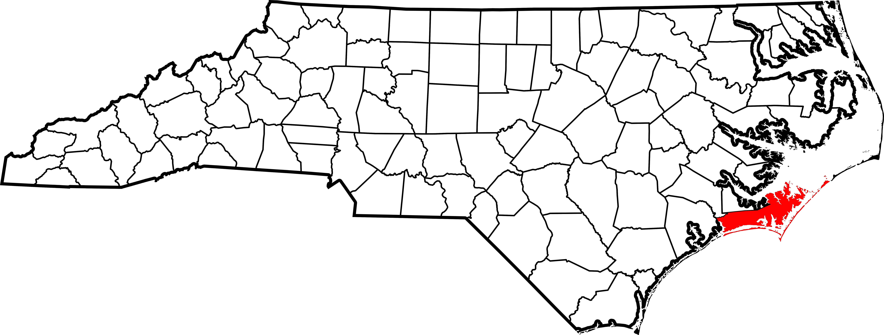
5. Where in the country is this energy source best suited? ______________________________
1. How is b. vudshuoHDUBased on the HSL

BFNDJSHuihvenergy made? Where does it come from?

2. Major uses:

3. How does energy source produce electricity? Highlight special equipment needed.

4. Contribution to total U.S. electricity generation: _________
5. Where in the country is this energy source best suited? _______________________________
6. Complete the

